Lab 11: Configuring One-to-One and Many-to-Many Relationships
Objective
To understand and implement Eager Loading and Explicit Loading for retrieving related data using Entity Framework Core.
Commands Used
dotnet run
Code
Program.cs
using Microsoft.EntityFrameworkCore;
using RetailInventory.Data;
using var context = new AppDbContext();
// Eager Loading
var products = context.Products
.Include(p => p.Category)
.ToList();
Console.WriteLine("Eager Loading");
Console.WriteLine("-------------");
foreach (var product in products)
{
Console.WriteLine($"Product : {product.Name}");
Console.WriteLine($"Price : {product.Price}");
Console.WriteLine($"Category : {product.Category.Name}");
Console.WriteLine();
}
// Explicit Loading
var firstProduct = context.Products.First();
context.Entry(firstProduct)
.Reference(p => p.Category)
.Load();
Console.WriteLine("Explicit Loading");
Console.WriteLine("----------------");
Console.WriteLine($"Product : {firstProduct.Name}");
Console.WriteLine($"Category : {firstProduct.Category.Name}");
Category.cs
using System.Collections.Generic;
namespace RetailInventory.Models
{
public class Category
{
public int Id { get; set; }
public string Name { get; set; }
public List<Product> Products { get; set; } = new List<Product>();
}
}Product.cs
namespace RetailInventory.Models
{
public class Product
{
public int Id { get; set; }
public string Name { get; set; }
public decimal Price { get; set; }
public int CategoryId { get; set; }
public Category Category { get; set; }
public int StockQuantity { get; set; }
}
}
AppDbContext.cs
using Microsoft.EntityFrameworkCore;
using RetailInventory.Models;
namespace RetailInventory.Data
{
public class AppDbContext : DbContext
{
public DbSet<Product> Products { get; set; }
public DbSet<Category> Categories { get; set; }
protected override void OnConfiguring(DbContextOptionsBuilder optionsBuilder)
{
optionsBuilder.UseSqlServer(
"Server=localhost\\SQLEXPRESS;Database=RetailDB;Trusted_Connection=True;TrustServerCertificate=True;");
}
protected override void OnModelCreating(ModelBuilder modelBuilder)
{
modelBuilder.Entity<Product>()
.Property(p => p.Price)
.HasPrecision(18, 2);
modelBuilder.Entity<Category>().HasData(
new Category { Id = 1, Name = "Electronics" },
new Category { Id = 2, Name = "Groceries" }
);
modelBuilder.Entity<Product>().HasData(
new Product
{
Id = 1,
Name = "Smartphone",
Price = 25000,
CategoryId = 1,
StockQuantity = 50
},
new Product
{
Id = 2,
Name = "Wheat Flour",
Price = 800,
CategoryId = 2,
StockQuantity = 100
}
);
}
}
}
Output
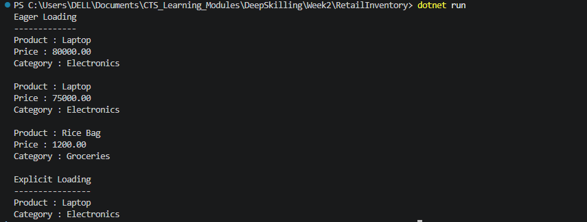
Result
The related category data was successfully retrieved using Eager Loading with Include() and Explicit Loading using Entry().Reference().Load(). This demonstrated different loading strategies available in Entity Framework Core.

